**SOFTWARE DEVELOPMENT LIFE CYCLE:**

Software development life cycle which is basically a cyclic process for the software developers to design, develop and test the software that they made. It includes the steps from start to the end of deployment to ensure the developer can make use to make their own software. There are many types of SDLC models down there to help us, three of the them are:

1. Water fall model

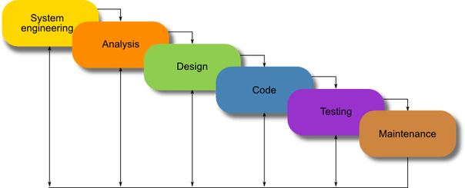

Water fall model was most widely used for software development. It provides great project scheduling as well as great structure for the project. This model preferred as it is very organised as it’s end product result in well constructed product. Its easy to describe our plan to our customers. Well, early detection of errors and bugs in combination with detail structured model sounds very conveniencing to used it for all types of software development. Requirement gathering is very important in this model , as an unclear requirements gathering and backwards rotation steps may result in huge damage for the project and cost a lot.

1. V – shaped model

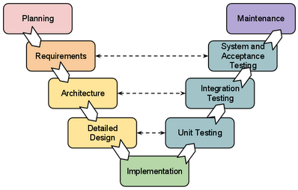

This is the best sounding and well defined model, all though it shares some similarities with water fall model it provides a great user friendly steps. It has mush specific requirement when each stage finish and also early verification and validation are the most identifying things in this model it also splits up the functions and made more steps to ensure great flexibility and bug verification. But it path for bugs is unclear change of requirements may cost a lot .

1. Iteration and incremental model

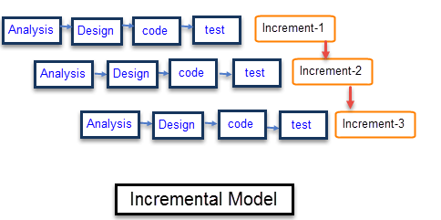

This model may overwrite the water fall model. Sometimes it’s a combination of mini water fall model sometimes mini v shaped model. Basically its structure consists of repeat cycle of certain model for at least three times though it provides better bug detection. But for this model more cons as its sequence it require more time, more customers, more documentation so on. It does offer a decent product with better value in development cycles but it does follows simple structure with multiple rotations to provide a good end product.